COVER PAGE

NAME : CHANTELL

SURNAME : MALEPE

INTRODUCTIN TO WEB

TABLE OF CONTENTS

INTRODUCTION PAGE 3

HOME & CODE PAGE 4 – 6

THE CSS CODE PAGE 7 – 8

MENU & CODE PAGE 9 – 19

ABOUT & CODE PAGE 20-23

CONTACT & CODE PAGE 24 – 27

REPORT PAGE 28

INTRODUCTION

Welcome to my website . I hope you find it of use and intriguing to use as for through out the who document.

THE “MANO GRINDERS COFFEE” is a website that promotes our delicious coffee in the most modern way with the use of technology. The way we provide our coffee is through our generosity, hearts and soul. Our coffee is provided with the accurate customer service that is sure to make an individual customers become motivated to come back more.

We promote a healthy hygienic environment that is visually pleasing to the eye. Visit our three branches lay in JOHANNESBURG, PRETORIA AND SANDTON. Further details can be found in our website.

AS WE LIKE TO SAY:

ENJOY YOUR STAY AND TASTE….

THANK YOU!!!

HOME PAGE

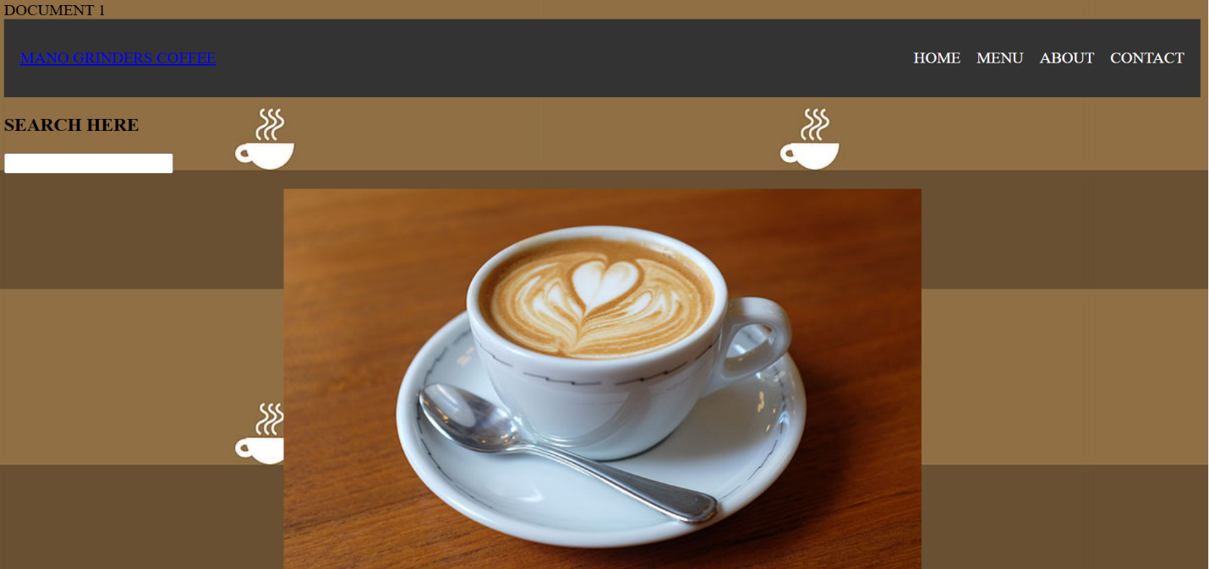

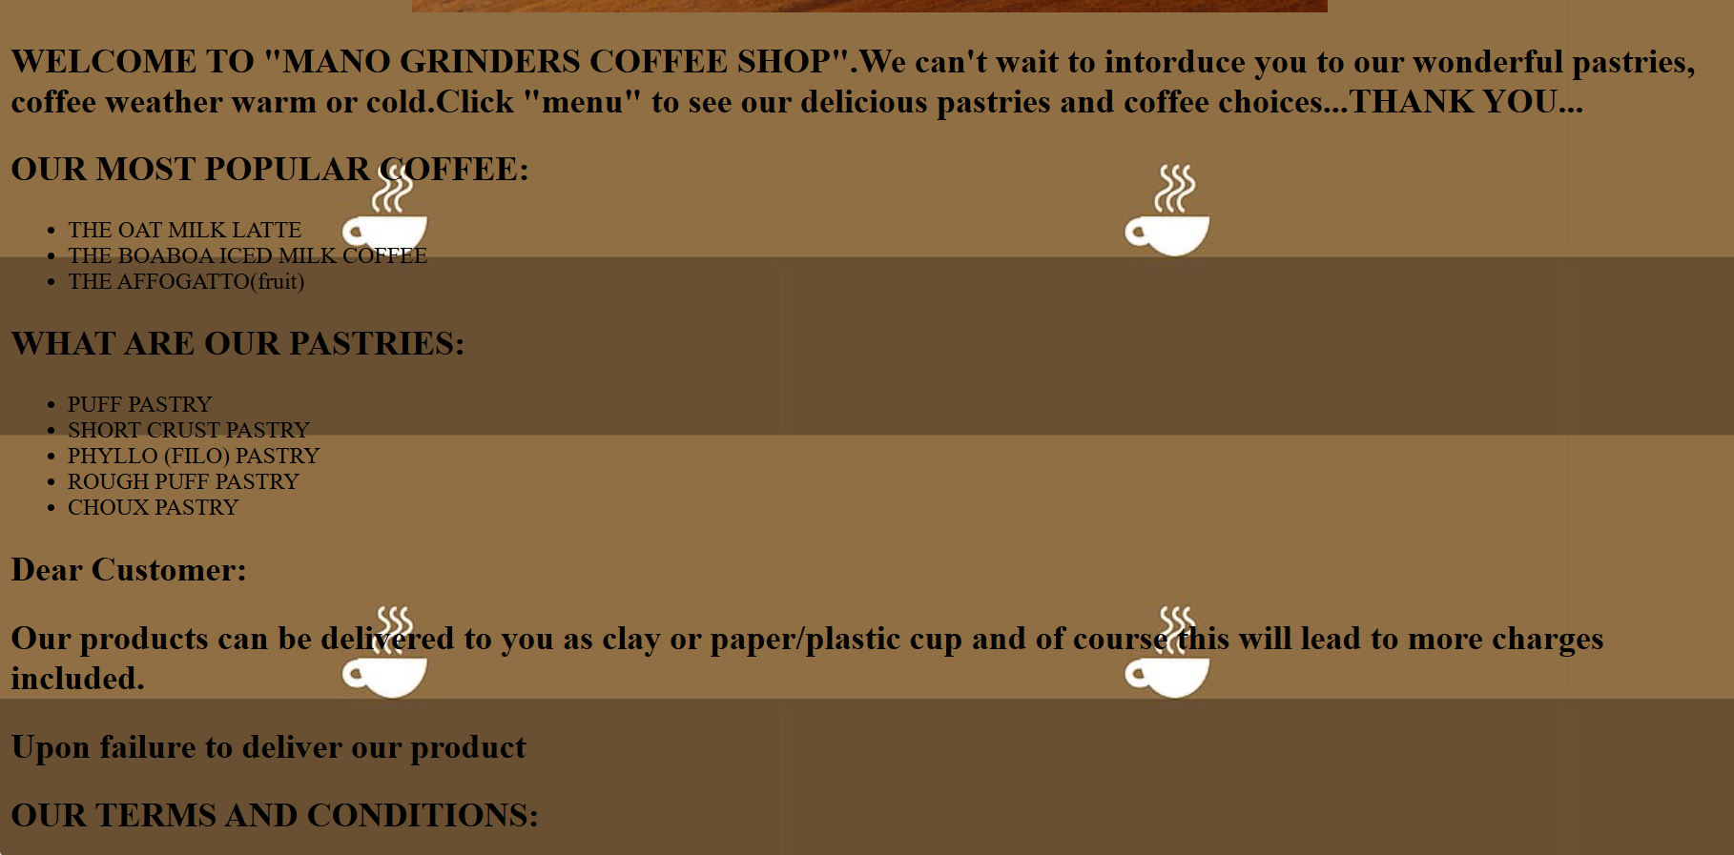

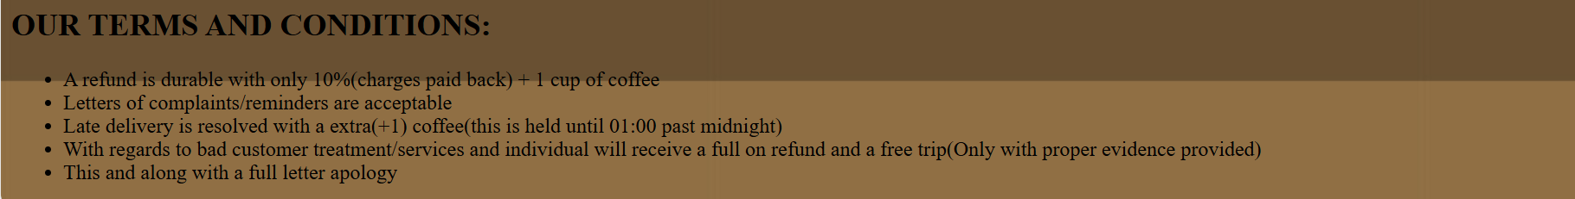

THE CODE:

<html>

<head>

<titel>DOCUMENT 1</titel>

<link rel="stylesheet" href="assignment.css">

<style>

body{

background-image= url("dubai.jpg");

background-size= cover;

background-repeat= no repeat;

background-postion= center;

}

</style>

</head>

<body background="dubai.jpg">

<header>

<nav>

<div class="MANO GRINDERS COFFEE">

<a href="#">MANO GRINDERS COFFEE</a>

</div>

<ul>

<li><a href="UNTITLED-3.html">HOME</a></li>

<li><a href="Fendi.html">MENU</a></li>

<li><a href="ASSIGNMENT3.html">ABOUT</a></li>

<li><a href="ASSIGNMENT4.html">CONTACT</a></li>

</ul>

</nav>

</header>

<h3>SEARCH HERE</h3>

<div class="box">

<input type="text" name="#">

</div>

<P align="center"><img src="meaning.jpg">

<h2><font color="black">WELCOME TO "MANO GRINDERS COFFEE SHOP".We can't wait to intorduce you to our wonderful pastries,coffee weather warm or cold.Click "menu" to see

our delicious pastries and coffee choices...THANK

YOU...</h2></font>

<h2><font color="black">OUR MOST POPULAR COFFEE:</h2></font>

<ul>

<li>THE OAT MILK LATTE</li>

<li>THE BOABOA ICED MILK COFFEE</li>

<li>THE AFFOGATTO(fruit)</li>

</ul>

<h2><font color="black">WHAT ARE OUR PASTRIES:</h2></font>

<ul>

<li>PUFF PASTRY</li>

<li>SHORT CRUST PASTRY</li>

<li>PHYLLO (FILO) PASTRY</li>

<li>ROUGH PUFF PASTRY</li>

<li>CHOUX PASTRY</li>

</ul>

<h2><font color="black">Dear Customer:</h2></font>

<h2><font color="black">Our products can be delivered to you

as clay or paper/plastic cup and of

course this will lead to more charges

included.</h2></font>

<h2><font color="black">Upon failure to deliver our product</h2></font>

<h2><font color="black">OUR TERMS AND CONDITIONS:</h2></font>

<ul>

<li>A refund is durable with only 10%(charges paid back) + 1 cup of coffee</li>

<li>Letters of complaints/reminders are acceptable</li>

<li>Late delivery is resolved with a extra(+1) coffee(this is held until 01:00 past midnight)</li>

<li>With regards to bad customer treatment/services and individual

will receive a full on refund and a free trip(Only with

proper evidence provided)</li>

<li>This and along with a full letter apology</li>

</ul>

</body>

</html>

THE CSS CODE:

The css:

nav{

display: flex;

justify-content: space-between;

align-items:center;

}

header{

background-color:#333;

color:#fff;

padding:1rem;

}

nav ul{

list-style-type: none;

display: flex;

}

nav ul li a{

margin-left:1rem;

}

nav ul li a{

color:#fff;

text-decoration: none;

}

.logo a{

color:#fff;

text-decoration: none;

font-weight: bold;

font size: 1,2rem;

}

<style>

.container {

display: flex;

justify-content: space-between;

}

.left-list, .right-list {

width: 30%;

padding: 20px;

background-color: burlywood;

border-radius: 5px;

}

h2 {

margin-top: 0;

}

</style>

MENU PAGE

THE MENU:

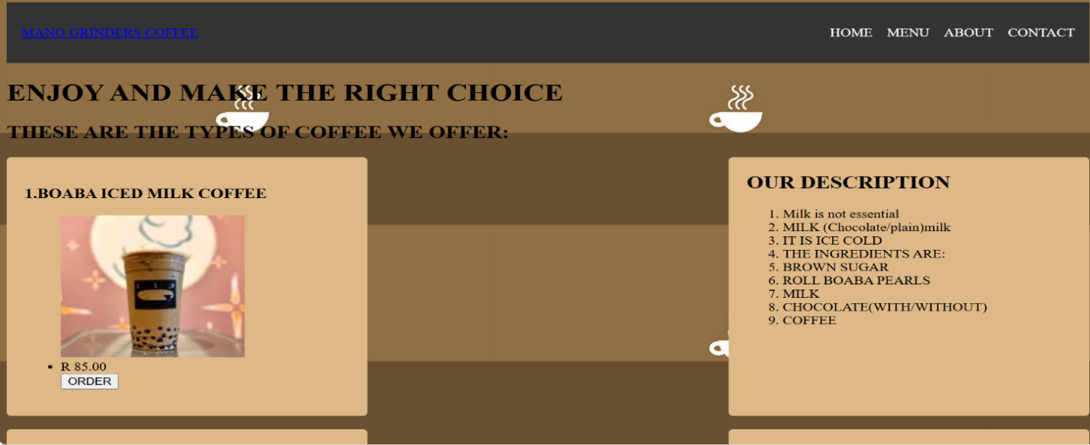

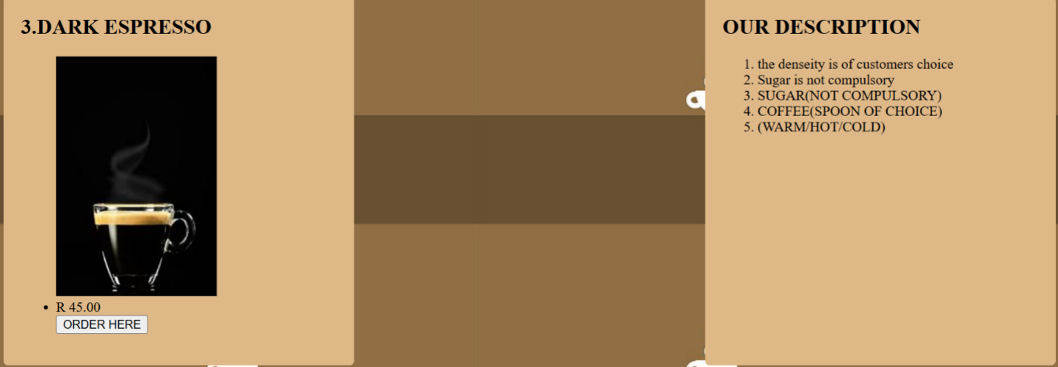

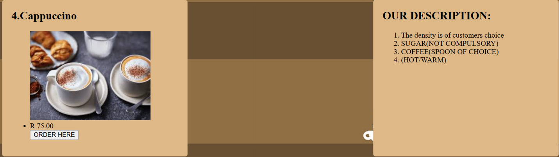

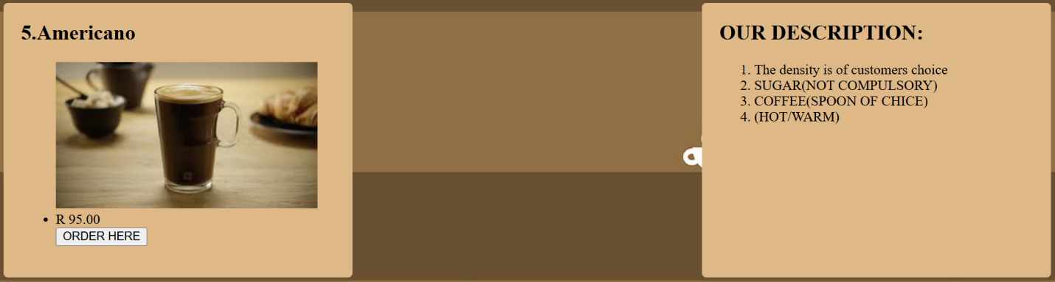

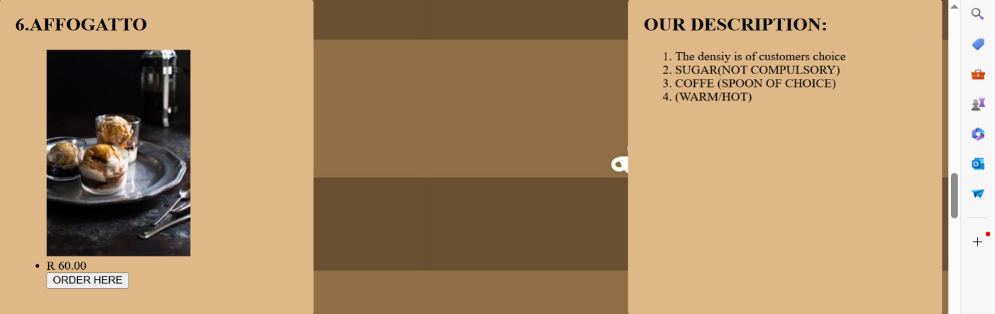

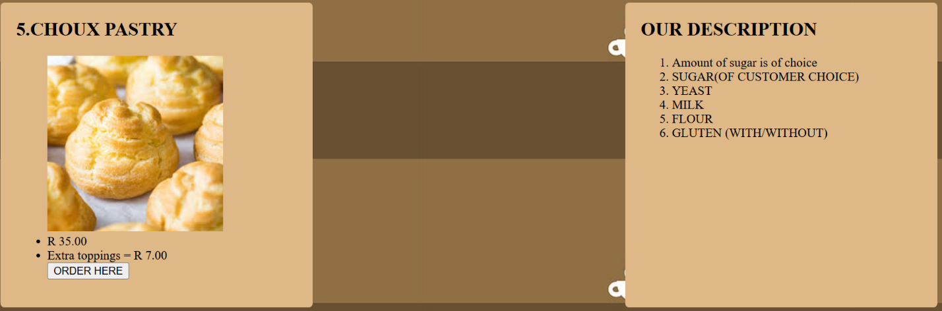

THE CODE FOR MENU:

<!DOCTYPE html>

<html lang="en">

<head>

<meta charset="UTF-8">

<meta name="viewport" content="width=device-width, initial-scale=1.0">

<title>DOCUMENT</title>

<link rel="stylesheet" href="assignment.css">

<style>

body{

background-image= url("dubai.jpg");

background-size= cover;

background-repeat= no repeat;

background-position= center;

}

</style>

</head>

<body background="dubai.jpg">

<header>

<nav>

<div class="MANO GRINDERS COFFEE">

<a href="#">MANO GRINDERS COFFEE</a>

</div>

<ul>

<li><a href="UNTITLED 3.html">HOME</a></li>

<li><a href="fendi.html">MENU</a></li>

<li><a href="ASSIGNMENT3.html">ABOUT</a></li>

<li><a href="ASSIGNMENT4.html">CONTACT</a></li>

</ul>

</nav>

</header>

<h1><font color="black">ENJOY AND MAKE THE RIGHT CHOICE</h1></font>

<h2><font color="black">THESE ARE THE TYPES OF COFFEE WE OFFER:</h2></font>

<div class="container">

<div class="left-list">

<h3>1.BOABA ICED MILK COFFEE</h3>

<ul>

<img src="two.jpeg">

<li>R 85.00</li>

<button>ORDER</button>

</ul>

</div>

<div class="right-list">

<h2>OUR DESCRIPTION</h2>

<ol>

<li>Milk is not essential</li>

<li>MILK (Chocolate/plain)milk</li>

<li>IT IS ICE COLD</li>

<li>THE INGREDIENTS ARE:</li>

<li>BROWN SUGAR</li>

<lI>ROLL BOABA PEARLS</lI>

<li>MILK</li>

<li>CHOCOLATE(WITH/WITHOUT)</li>

<lI>COFFEE</lI>

</ol>

</div>

</div>

<BR>

<div class="container">

<div class="left-list">

<h2>2.OAT MILK LATTE</h2>

<ul>

<img src="oat.jpeg">

<li>R 35.00</li>

<button>ORDER HERE</button>

</ul>

</div>

<div class="right-list">

<h2>OUR DESCRIPTION:</h2>

<ol>

<li>Extra topings R7.00</li>

<li>Sugar is free of charge!!!</li>

<li>Can be warm/cold</li>

<li>THE INGREDIENTS ARE:</li>

<li>OATS</li>

<li>MILK</li>

<li>COFFEE</li>

<li>SUGAR(WHITE/BROWN)</li>

<li>MILK(WITH/WITHOUT)</li>

</ol>

</div>

</div>

<br>

<div class="container">

<div class="left-list">

<h2>3.DARK ESPRESSO</h2>

<ul>

<img src="ten.jpeg">

<li>R 45.00</li>

<button>ORDER HERE</button>

</ul>

</div>

<div class="right-list">

<h2>OUR DESCRIPTION</h2>

<ol>

<li>the denseity is of customers choice</li>

<li>Sugar is not compulsory</li>

<li>SUGAR(NOT COMPULSORY)</li>

<li>COFFEE(SPOON OF CHOICE)</li>

<li>(WARM/HOT/COLD)</li>

</ol>

</div>

</div>

<br>

<div class="container">

<div class="left-list">

<h2>4.Cappuccino</h2>

<ul>

<img src="eleven.jpeg">

<li>R 75.00</li>

<button>ORDER HERE</button>

</ul>

</div>

<div class="right-list">

<h2>OUR DESCRIPTION:</h2>

<ol>

<li>The density is of customers choice</li>

<li>SUGAR(NOT COMPULSORY)</li>

<li>COFFEE(SPOON OF CHOICE)</li>

<li>(HOT/WARM)</li>

</ol>

</div>

</div>

<br>

<div class="container">

<div class="left-list">

<h2>5.Americano</h2>

<ul>

<img src="thirteen.jpeg">

<li>R 95.00</li>

<button>ORDER HERE</button>

</ul>

</div>

<div class="right-list">

<h2>OUR DESCRIPTION:</h2>

<ol>

<li>The density is of customers choice</li>

<li>SUGAR(NOT COMPULSORY)</li>

<li>COFFEE(SPOON OF CHICE)</li>

<li>(HOT/WARM)</li>

</ol>

</div>

</div>

<br>

<div class="container">

<div class="left-list">

<h2>6.AFFOGATTO</h2>

<ul>

<img src="fifteen.jpeg">

<li>R 60.00</li>

<button>ORDER HERE</button>

</ul>

</div>

<div class="right-list">

<h2>OUR DESCRIPTION:</h2>

<ol>

<li>The densiy is of customers choice</li>

<li>SUGAR(NOT COMPULSORY)</li>

<li>COFFE (SPOON OF CHOICE)</li>

<li>(WARM/HOT)</li>

</ol>

</div>

</div>

<br>

<div class="container">

<div class="left-list">

<h2>7.CORTADOR COFFEE</h2>

<ul>

<img src="twenty.jpeg">

<li>R 65.00</li>

<button>ORDER HERE</button>

</ul>

</div>

<div class="right-list">

<h2>OUR DESCRIPTION:</h2>

<ol>

<li>MILK(NOT COMPULSORY)</li>

<li>SUGAR(NOT COMPULSORY)</li>

<li>COFFEE (SPOON OF CHOICE)</li>

<li>(WARM?HOT)</li>

</ol>

</div>

</div>

<br>

<h4><font color="black">WE GENUINELY UNDERSTAND THAT CUSTOMERS

HEALTH IS OF OUR RELEVENCY IN OUR STORE.

WHICH IS WHY WE OFFER A CHOICE FOR OUR

CUSTOMERS TO CHOOSE THE AMOUNT OF SUGAR

THAT THEY COULD WANT IN THEIR PASTRIES.

AS THEY WILL BE READY WITH MIXTURES BUT

WAITING FOR OUR CUSTOMERS SAY ON SUGAR.

THIS REDUCED ANY HARZARDS ON COLASTOROL.

THE SAME APPLIES TO OUR COOCKIES AND

BUISCUITS.WE CARE ABOUT YOU !!!</h4></font>

<h1><center><font color="black">WHAT ARE OUR PASTRIES</h1></center></font>

<h2><font color="black">WITH REGARDS TO ALERGENS MOST OF OUR PASTRIES CONTAIN NUTS,GLUTEN AND MILK.</font></h2>

<div class="container">

<div class="left-list">

<h2>1.PUFF PASTRY</h2>

<ul>

<img src="short.jpeg">

<li>R 20.00</li>

<li>Extra topings = R 8.00</li>

<button>ORDER HERE</button>

</ul>

</div>

<div class="right-list">

<h2>OUR DESCRIPTION:</h2>

<ol>

<li>Amount of sugar is off customers choice</li>

<li>SUGAR(OF CUSTOMER CHOICE)</li>

<li>YEAST</li>

<li>MILK</li>

<li>FLOUR</li>

<li>GLUTEN (WITH/WITHOUT)</li>

</ol>

</div>

</div>

<br>

<div class="container">

<div class="left-list">

<h2>2.SHORT CRUST PASTRY</h2>

<ul>

<img src="PUFF.jpeg">

<li>R 40.00</li>

<li>Extra toppings = R 10.00</li>

<button>ORDER HERE</button>

</ul>

</div>

<div class="right-list">

<h2>OUR DESCRIPTION:</h2>

<ol>

<li>Amount of sugar is of customers choice</li>

<li>SUGAR(OF CUSTOMER CHOICE)</li>

<li>YEAST</li>

<li>MILK</li>

<li>FLOUR</LI>

<li>GLUTEN (WITH/WITHOUT)</li>

</ol>

</div>

</div>

<BR>

<div class="container">

<div class="left-list">

<h2>3.PHYLLO CRUST PASTRY</h2>

<ul>

<img src="Phyllo.jpeg">

<li>R 30.00</li>

<li>Extra toppings = R 10.00</li>

<button>ORDER HERE</button>

</ul>

</div>

<div class="right-list">

<h2>OUR DESCRIPTION:</h2>

<ol>

<li>Amount of sugar is off customers choice</li>

<li>SUGAR(OF CUSTOMER CHOICE)</li>

<li>YEAST</li>

<li>MILK</li>

<li>FLOUR</LI>

<li>GLUTEN (WITH/WITHOUT)</li>

</ol>

</div>

</div>

<br>

<div class="container">

<div class="left-list">

<h2>4.PHYLLO(FILO)PASTRY</h2>

<ul>

<img src="rough.jpeg">

<li>R 35.00</li>

<li>Extra toppings = R 7.00</li>

<Button>ORDER HERE</Button>

</ul>

</div>

<div class="right-list">

<h2>Right List</h2>

<ol>

<li>Amount of sugar is of choice</li>

<li>SUGAR(OF CUSTOMER CHOICE)</li>

<li>YEAST</li>

<li>MILK</li>

<li>FLOUR</LI>

<li>GLUTEN (WITH/WITHOUT)</li>

</ol>

</div>

</div>

<br>

<div class="container">

<div class="left-list">

<h2>5.CHOUX PASTRY</h2>

<ul>

<img src="choux.jpeg">

<li>R 35.00</li>

<li>Extra toppings = R 7.00</li>

<button>ORDER HERE</button>

</ul>

</div>

<div class="right-list">

<h2>OUR DESCRIPTION</h2>

<ol>

<li>Amount of sugar is of choice</li>

<li>SUGAR(OF CUSTOMER CHOICE)</li>

<li>YEAST</li>

<li>MILK</li>

<li>FLOUR</LI>

<li>GLUTEN (WITH/WITHOUT)</li>

</ol>

</div>

</div>

<br>

ABOUT PAGE

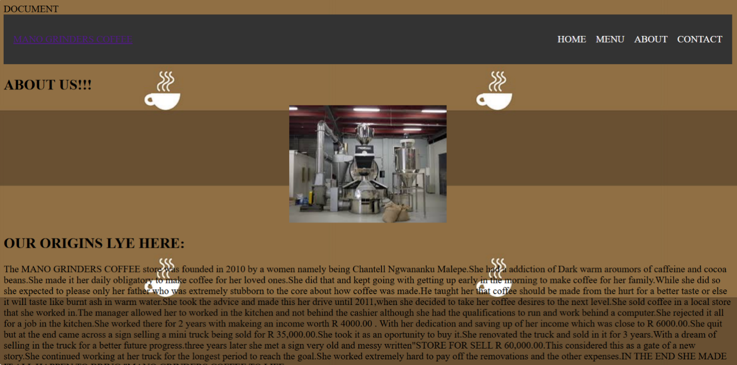

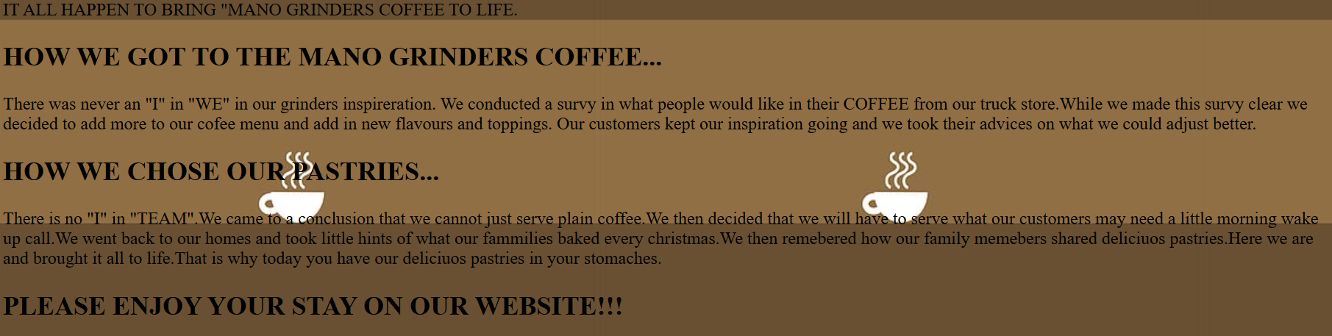

THE ABOUT US CODE:

<html>

<head>

<titel>DOCUMENT</titel>

<link rel="stylesheet" href="assignment.css">

<style>

body{

background-image= url("dubai.jpg");

background-size= cover;

background-repeat= no repeat;

background-position= center;

}

</style>

</head>

<body background="dubai.jpg">

<header>

<nav>

<div class="MANO GRINDERS COFFEE">

<a href="#">MANO GRINDERS COFFEE</a>

</div>

<ul>

<li><a href="UNtitled-3.html">HOME</a></li>

<li><a href="fendi.html">MENU</a></li>

<li><a href="ASSIGNMENT3,html">ABOUT</a></li>

<li><a href="ASSIGNMENT.html">CONTACT</a></li>

</ul>

</nav>

</header>

</BODY>

<h2><font color="black">ABOUT US!!!</h2></font>

<P align="center"><img src="factory.jpeg"></P>

<h2><font color="black"> OUR ORIGINS LYE HERE:</H2></font>

<P><font color="black">The MANO GRINDERS COFFEE store was founded in 2010

by a women namely being Chantell Ngwananku Malepe.She had

a addiction of Dark warm aroumors of caffeine and cocoa

beans.She made it her daily obligatory to make coffee

for her loved ones.She did that and kept going with

getting up early in the morning to make coffee for

her family. While she did so she expected to please

only her father who was extremely stubborn to the

core about how coffee was made. He taught her that

coffee should be made from the hurt for a better

taste or else it will taste like burnt ash in warm

water. She took the advice and made this her drive

until 2011,when she decided to take her coffee

desires to the next level. She sold coffee in a

local store that she worked in. The manager allowed

her to worked in the kitchen and not behind the

cashier although she had the qualifications to

run and work behind a computer. She rejected it

all for a job in the kitchen. She worked there

for 2 years with making an income worth R 4000.00 .

With her dedication and saving up of her income

which was close to R 6000.00.She quit but at the

end came across a sign selling a mini truck being

sold for R 35,000.00.She took it as an opportunity

to buy it.She renovated the truck and sold in it

for 3 years. With a dream of selling in the truck

for a better future progress. Three years later

she met a sign very old and messy written “STORE

FOR SELL R 60,000.00.This considered this as a

gate of a new story. She continued working at her

truck for the longest period to reach the goal. She

worked extremely hard to pay off the renovations and

the other expenses.IN THE END SHE MADE IT ALL HAPPEN

TO BRING "MANO GRINDERS COFFEE TO LIFE.</P></font>

<H2><font color="black">HOW WE GOT TO THE MANO GRINDERS COFFEE...</H2></FONT>

<p><FONT COLOR="BLACK">There was never an "I" in "WE" in our grinders inspireration.

We conducted a survy in what people would like in their COFFEE

from our truck store.While we made this survy clear we decided

to add more to our cofee menu and add in new flavours and toppings.

Our customers kept our inspiration going and we took their advices

on what we could adjust better.</P></font>

<H2><FONT COLOR="black">HOW WE CHOSE OUR PASTRIES...</H2></font>

<P><font color="black">There is no "I" in "TEAM".We came

to a conclusion that we cannot just serve

plain coffee. We then decided that we will

have to serve what our customers may need

a little morning wake up call. We went back

to our homes and took little hints of what

our families baked every Christmas. We then

remembered how our family members shared

delicious pastries. Here we are and brought

it all to life. That is why today you have

our delicious pastries in your stomaches.</p></FONT>

<h2><font color="black">PLEASE ENJOY YOUR STAY ON OUR WEBSITE!!!</h2></font>

</body>

</html>

CONTACT PAGE:

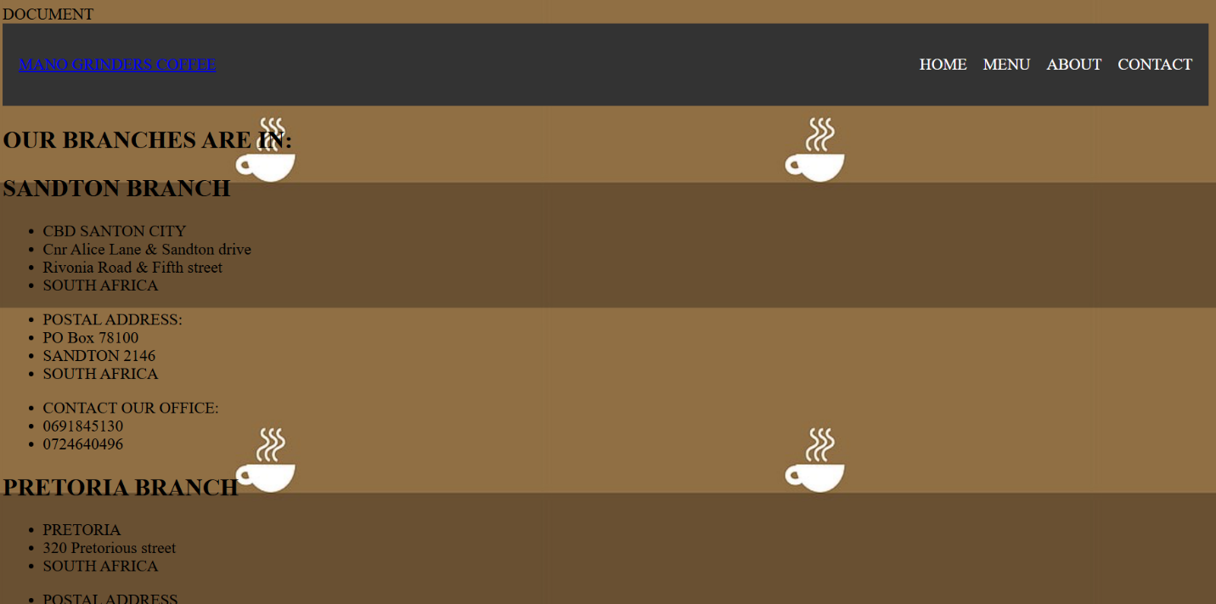

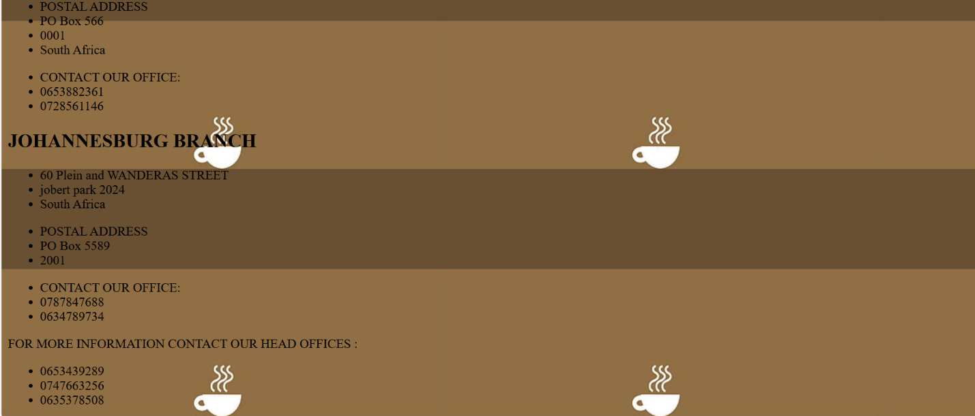

THE CODE FOR CONTACT PAGE:

<html>

</head>

<titel>DOCUMENT</titel>

<link rel="stylesheet" href="assignment.css">

<style>

body{

background-image= url("dubai.jpg");

background-size= cover;

background-repeat= no repeat;

background-postion= center;

}

</style>

</head>

<body background="dubai.jpg">

<header>

<nav>

<div class="MANO GRINDERS COFFEE">

<a href="#">MANO GRINDERS COFFEE</a>

</div>

<ul>

<li><a href="Untiteled-3.html">HOME</a></li>

<li><a href="fendi.html">MENU</a></li>

<li><a href="ASSIGNMENT3.html">ABOUT</a></li>

<li><a href="ASSIGNMENT4.html">CONTACT</a></li>

</ul>

</nav>

</header>

</BODY>

<H2><FONT COLOR="BLACK">OUR BRANCHES ARE IN:</H2></font>

<h2><font color="black">SANDTON BRANCH</font></h2>

<ul>

<li>CBD SANTON CITY</li>

<li>Cnr Alice Lane & Sandton drive</li>

<li>Rivonia Road & Fifth street</li>

<li>SOUTH AFRICA</li>

</ul>

<ul>

<li>POSTAL ADDRESS:</li>

<li>PO Box 78100</li>

<li>SANDTON 2146</li>

<li>SOUTH AFRICA</li>

</ul>

<ul>

<li>CONTACT OUR OFFICE:</li>

<li>0691845130</li>

<li>0724640496</li>

</ul>

<h2><font color="black">PRETORIA BRANCH</font></h2>

<UL>

<li>PRETORIA</li>

<li>320 Pretorious street</li>

<li>SOUTH AFRICA</li>

</UL>

<ul>

<li>POSTAL ADDRESS</li>

<li>PO Box 566</li>

<li>0001</li>

<li>South Africa</li>

</ul>

<ul>

<li>CONTACT OUR OFFICE:</li>

<LI>0653882361</LI>

<li>0728561146</li>

</ul>

<h2><font color="black">JOHANNESBURG BRANCH</font></h2>

<ul>

<li>60 Plein and WANDERAS STREET</li>

<li>jobert park 2024</li>

<li>South Africa</li>

</ul>

<ul>

<li>POSTAL ADDRESS</li>

<li>PO Box 5589</li>

<li>2001</li>

</ul>

<ul>

<li>CONTACT OUR OFFICE:</li>

<li>0787847688</li>

<li>0634789734</li>

</ul>

<P><FONT COLOR="BLACK">FOR MORE INFORMATION CONTACT OUR HEAD OFFICES :</FONT></P>

<ul>

<li>0653439289</li>

<li>0747663256</li>

<li>0635378508</li>

</ul>

</body>

</html>

Report

explaining your design choices, challenges faced, and what you learned during the project.

With regards to my success and challenges being reached throughout the project. I will first of begin with my challenges which were designing of the menu. I had a solemn difficulty with accessing the best code for my vision. This had led to me being in desperate for assistance of multiple sources. I wanted the menu to be both left and right aligned at the same sequence with no enjambment included. I averted myself from making every design the same throughout the other websites as it would have shown less effort providence. This project has led me to believe that hard work comes at an extravagant sacrifice. Were as in this case I sacrificed my daily relaxation and hobbies to achieve my dream.